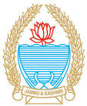**Office of the Principal**

**Government Degree College Uttersoo**

*گورنمنٹ* ڈگری کالج اُترسو(کشمیر)

***Uttersoo-Shangus - 192201 - (Distt. Anantnag) – Kashmir***

**Email: gdc.uttersoo@gmail.comNAAC Accredited Grade “B”(CGPA 2.33)Web:** [**www.gdcut.ac.in**](http://www.gdcut.ac.in)

**Ph. No. 9419065616 Landline:- 01932-29317**

**No: GDCUT/2025/ Dated: 26/01/2025**

**Govt. Degree Colleege Uttersoo celebrated 76th Republic Day**

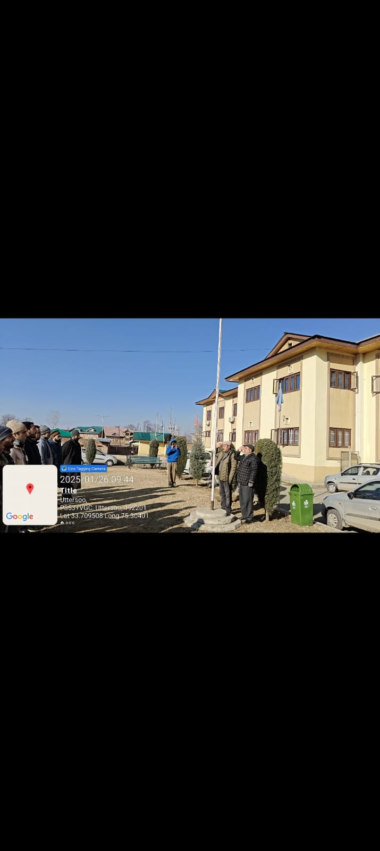

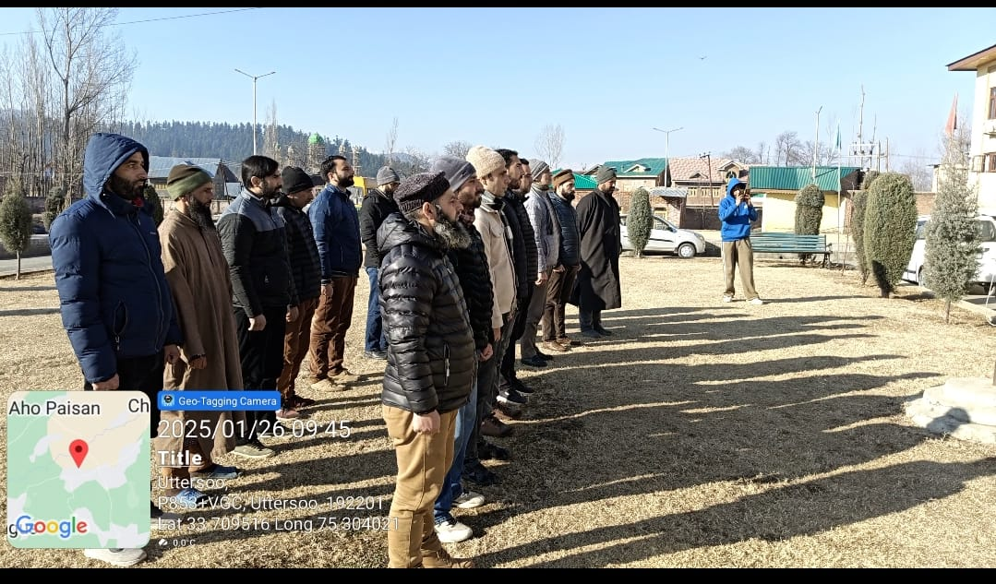

Government Degree College, Uttersoo celebrated the 76th Republic Day of India with great zeal and enthusiasm. The event commenced with the ceremonial unfurling of the national flag, followed by the singing of the national anthem, which filled the atmosphere with patriotic fervour. The worthy Principal, Professor Mushtaq Ahmed Sohil, addressed the gathering, comprising teaching and non teaching staff and students. In his insightful speech, he emphasized the historical significance of January 26, 1950, the day when the Constitution of India came into effect, marking the nation’s transition to a sovereign, democratic, and republic state. He reflected on the remarkable progress India has made since then in various spheres and highlighted the critical role of the Constitution in shaping the country’s journey.  In addition, the Principal highlighted various developmental activities of the college including the construction of the administrative block, health centre, botanical garden, and playground that happened in his tenure. The vote of thanks was delivered by Mr. Basharat Hussain Bhat, Head of the Department of Economics. He expressed his gratitude to the Principal, the senior-most faculty member Professor Nazeer Ahmed Wani, all faculty members, and students for their valuable presence despite the harsh winter cold. He acknowledged their unwavering support and dedication, which made the event a grand success. The celebration ended on a note of unity, patriotism, and shared commitment to excellence, leaving everyone inspired and motivated. Professor Nazir Ahmad Wani arranged refreshments for all the participants.

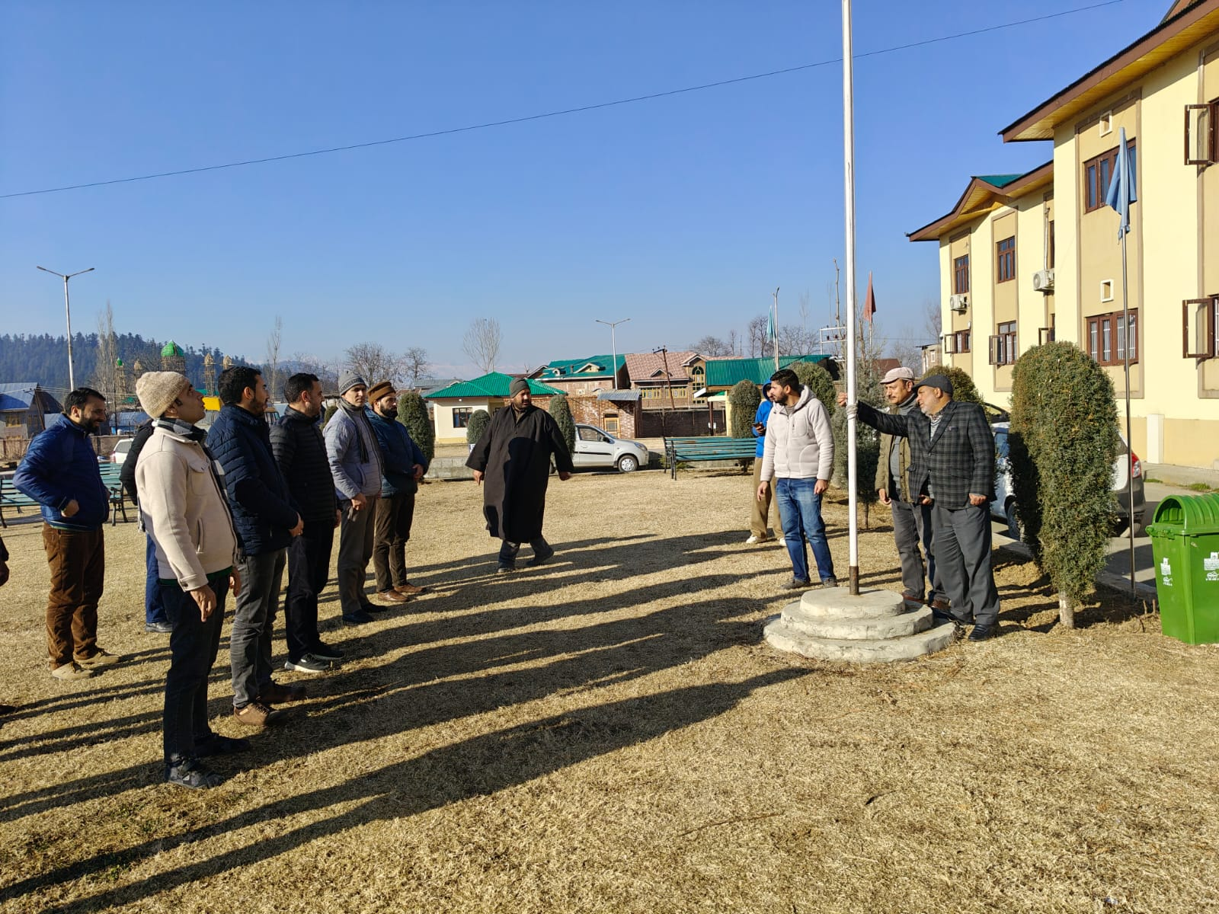

SD/- SD/-

**Dr. Tariq Bashir Principal**

Convener, Debates and Seminars